ENTRY BLANK
MERCER COUNTY FAIR, ALEDO, ILLINOIS 61231


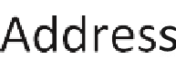



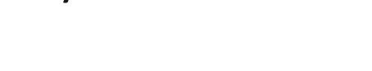




All purebreds must be registered in their respective breed association in the exhibitor’s name. Exhibitors must have a photocopy of registration papers to turn in to the superintendent.


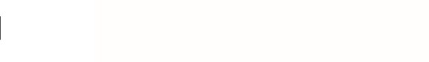


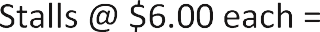




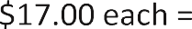

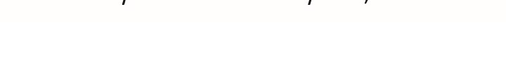

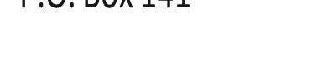
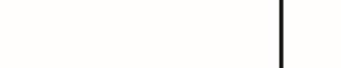

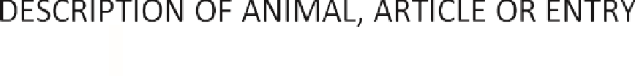



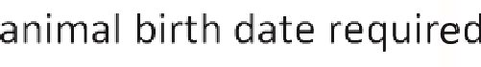
NUMBER

ALL ENTRIES MUST BE POSTMARKED BY June 27, 2025.
All livestock premium checks may be picked up in the Secretary’s Office following the completion of the shows and must be picked up by 5:00 p.m. on Saturday, July 12, 2025. All receipts must be signed for.

